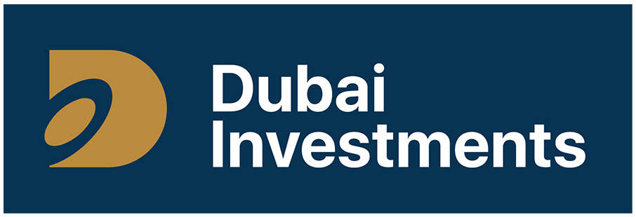
Business Requirements Document
PMO Project Dashboard
Solution | PMO Project Dashboard and Portal
Organisation | Dubai Investments PJSC and Group entities
Version / date | 1.0 · 19-Sep-2026
Status | Issued for business approval
Prepared by | Nayyar Jawaid
Document owner | Project Management Office
Approval | Signature page at section 10
Classification | [Internal]
REPORTING ENTITIES
 |  |  | 
Values shown in square brackets are to be confirmed before sign-off. Data in the screen designs is sample data.

1. Purpose and background
This document defines the business requirements for a PMO Project Dashboard, to be delivered using MS Technologies. It is issued for business approval and, once approved, becomes the baseline for build, testing and acceptance.
Project status is currently collected by e-mail and consolidated by hand into a management pack. Information is spread across documents, status is described in free text, there is no retained history of how a project reached its position, and risks often reach management only after they have caused delay. The result is that management decisions rest on information that is already out of date, and PMO effort is spent assembling reports rather than analysing them.
The portal reports the portfolio of Dubai Investments PJSC and its reporting entities: Dubai Investments Park, Dubai Investment Real Estate, Properties Investment and Al Taif Investment. Each project record carries its owning entity, so the portfolio can be viewed as a whole or one entity at a time.

2. Objectives
Ref | Objective | Success measure
OBJ-01 | A single dashboard showing the current status of every project in the portfolio. | Manual status pack withdrawn at go-live.
OBJ-02 | Standardised recording of status, progress and phase across all entities. | 100% of active projects using the controlled status values.
OBJ-03 | Removal of manual consolidation effort from the reporting cycle. | PMO consolidation effort reduced by at least [target %].
OBJ-04 | Risks, issues and decisions needed from management visible as soon as raised. | Every High severity risk visible on the day it is raised.
OBJ-05 | A complete, dated history of project updates. | Full history available for every active project.
OBJ-06 | Automatic prompting when an update or a milestone is due. | At least [target %] updated within the agreed cycle.

3. Scope
In scope
PMO portal with a management dashboard home page.
Microsoft Lists for projects, milestones, risks and issues, and updates.
A structured update form as the single point of data entry.
Project detail page with milestones, risks and full update history.
Power Automate reminders, alerts and escalations.
Power BI executive reporting and trend analysis.
Role-based permissions, including external consultants.
Migration of active projects, open milestones and open risks.

4. Solution design

4.1 Architecture
Three layers, with the Microsoft Lists as the single source of truth. No figure shown to management is maintained by hand anywhere else, and every value can be traced to a dated update and a named person.
Layer | Component | Purpose
1 — Data | Microsoft Lists | Projects, milestones, risks and issues, updates and reference data.
2 — Operations | Online portal | Dashboard, project detail pages, update form and document storage.
2 — Automation | Power Automate | Reminders, status-change alerts, escalations and the scheduled digest.
3 — Analytics | Power BI | Executive reporting, portfolio trends and scheduled distribution.

4.2 Design principles
- Data is captured once, at source, by the person accountable for it.
- Management views are read-only; the dashboard cannot be edited by the people reading it.
- Controlled choice fields are used wherever a value will be counted, filtered or reported.
- Nothing is deleted. Records are closed or cancelled, and corrections are made by a later update.
- Standard Microsoft 365 configuration is used in preference to custom code, so it can be supported in-house.

4.3 Data model
List | Holds | Key fields
PMO Projects | One master record per project. | Project ID, name, entity, department, owner, business owner, PM, consultant, status, progress %, phase, priority, start, target date, next action and owner, key update, attention flag, last update date.
Project Milestones | Milestones per project. | Project, milestone, planned date, baseline date, actual date, status, completion %, owner.
Risks and Issues | Risks and issues per project. | Project, type, description, severity, owner, mitigation, due date, status, closure note.
Project Updates | Dated history of submitted updates. | Project, update date, status, progress %, phase, key update, achievement, next action, attention flag, submitted by and on.
Reference lists | Controlled values. | Entities, departments, phases, consultants, statuses, priorities.
Relationship: PMO Projects is the parent; milestones, risks and updates are many-to-one against it.

5. Functionality

5.1 Functional requirements
Priority: Must (required for go-live), Should (required, may follow shortly after), Could (desirable).
Ref | Requirement | Priority
FR-01 | One record per project in a single register, covering every project across all reporting entities, each with a unique Project ID. | Must
FR-02 | Overall status selected from a controlled list: On Track, At Risk, Delayed, On Hold, Completed. Free-text status is not possible. | Must
FR-03 | Progress recorded as a whole number between 0 and 100 per cent. | Must
FR-04 | Project Owner, Business Owner and Project Manager recorded from the corporate directory; consultant or vendor from a controlled list. | Must
FR-05 | Only the PMO may create, close or reopen a project. Closed projects are excluded from default views but retained for reporting. | Must
FR-06 | Any number of milestones per project, each with planned date, actual or forecast date, owner, status and completion. | Must
FR-07 | The next milestone is derived as the earliest incomplete milestone by planned date, and shown on the dashboard. | Must
FR-08 | Milestones past their planned date and not complete are flagged as overdue in every view. | Must
FR-09 | Risks and issues recorded against the parent project with type, description, severity, owner, mitigation, due date and status. | Must
FR-10 | The count of open High severity items shown on the project record and the dashboard; closed items retained with a closure note. | Must
FR-11 | Project managers submit updates through a dedicated form; direct editing of dashboard content is not possible. | Must
FR-12 | On submission the system updates the project record, writes a dated entry to the update history, and stamps the last update date and submitting user. | Must
FR-13 | Submitted updates are read-only; a correction is made by submitting a later update. | Must
FR-14 | Full update history viewable in date order, showing how status and progress have moved. | Must
FR-15 | The form defaults to the values of the previous update, so the manager edits rather than retypes. | Should
FR-16 | Dashboard summary indicators: active projects, on track, at risk, delayed, average progress and items needing management attention. | Must
FR-17 | Portfolio table showing project, owner and consultant, status, progress, phase, next milestone, due date and last update. | Must
FR-18 | Status shown using the agreed colour convention and stated in text, so colour is not the only indicator. | Must
FR-19 | Selecting a project opens its detail page: overview, progress, milestones, risks and issues, and update history. | Must
FR-20 | Dashboard lists milestones due in a rolling window and the items flagged for management attention. | Must
FR-21 | Filtering by entity, department, status, priority, owner and consultant across the dashboard and views. | Must
FR-22 | A submitted update is reflected on the dashboard without manual intervention. | Must
FR-23 | Standard views for: at risk and delayed, overdue milestones, open high risks, and projects not updated within the agreed period. | Must
FR-24 | Portfolio view exportable to Excel and PDF for meeting papers; one-page project status report as PDF. | Should
FR-25 | A "My projects" view for each project manager, and search by project name, ID, owner and consultant. | Should
FR-26 | Documents attachable to the project record and to an individual update. | Should

5.2 Business rules
Ref | Rule
BR-01 | Status definitions are fixed: On Track — delivering to plan. At Risk — an identified threat could cause a milestone or the completion date to be missed. Delayed — a milestone or the completion date has already been missed. On Hold — formally paused. Completed — delivered and accepted.
BR-02 | A status of At Risk or Delayed requires a key update stating the cause and the recovery action.
BR-03 | Management attention set to Yes requires a reason before the update can be submitted.
BR-04 | A project set to Completed must be at 100% with no open milestones.
BR-05 | Progress may not decrease without an explanation in the key update.
BR-06 | An active project with no update in the agreed period is reported as Not Reported, distinguishing "no news" from "on track".
BR-07 | Projects, milestones, risks and updates are never deleted; they are closed or cancelled, preserving the audit trail.

5.3 Automated notifications
Ref | Trigger | Action and recipients
WF-01 | Status changes to At Risk. | Notify PMO and Project Owner immediately, with cause and recovery action.
WF-02 | Status changes to Delayed. | Escalation to PMO, Project Owner and Sponsor immediately.
WF-03 | Management attention flagged. | Notify PMO and the management distribution list, with the stated reason.
WF-04 | Milestone due within [7] days, or overdue. | Reminder to the milestone owner, copy the project manager; overdue notices repeat daily.
WF-05 | No update for [7] days / [14] days. | Reminder to the project manager, then escalation to the Project Owner.
WF-06 | Risk or issue raised at High severity. | Notify PMO and Project Owner immediately.
WF-07 | Scheduled, [Monday 08:00]. | Portfolio digest to management: counts by status, exceptions and upcoming milestones.
WF-08 | Project set to Completed. | Notify PMO to begin the closure checklist.
Recipients, intervals and thresholds in brackets are confirmed at design. Every notification links directly to the relevant record.

5.4 Reporting
Provides operational views: portfolio status, exceptions, upcoming and overdue milestones, open risks, and update history. Power BI provides the executive layer, reading from the same lists with no figures maintained inside the report:
- Portfolio summary and counts by status; projects by entity, department, owner and consultant.
- Delayed and at-risk projects with cause and recovery action; high severity risks and overdue actions.
- Status trend and progress trend over time, built from the update history.
- Milestone slippage (planned against actual) and completion throughput per period.
- Reporting compliance: projects updated within the agreed cycle.

6. Roles and permissions
Role | Can do | Cannot do
Management / Executive | View the dashboard, all projects and all reports. | Enter or amend any data.
PMO Administrator | Full control of lists, reference data, project creation and closure, permissions. | Amend a historical update without an audit record.
Project Manager | Submit updates, maintain milestones, risks and issues for their own projects. | Create or close projects; edit another manager’s projects or a submitted update.
Project Owner | View everything; confirm status on their own projects. | Submit updates on the manager’s behalf unless agreed.
Consultant / Vendor | Submit updates and maintain milestones and risks for contracted projects only. | See any other project or portfolio-wide views.
IT Support | Site administration, flow maintenance and incident support. | Amend project data as a matter of routine.
Access is granted through security groups, not to named individuals. External consultants use a governed guest account limited to their own projects, reviewed at the end of each engagement. Version history is enabled on all lists and anonymous sharing links are not permitted.

7. Non-functional requirements
Area | Requirement
Performance | Dashboard loads within [3] seconds and list views within [5] seconds for up to [500] projects.
Data currency | A submitted update is visible on the dashboard within [1] minute; Power BI shows its last refresh time.
Capacity | At least [500] projects, [10,000] milestones and risks and [50,000] updates, using indexed columns and filtered views.
Usability | A routine update can be completed in under [5] minutes without a manual.
Accessibility | WCAG 2.1 AA, including contrast, keyboard navigation and status conveyed by text as well as colour.
Devices | Current Edge, Chrome and Safari
Auditability | Every change attributable to a named user with date and time.
Licensing | Operates within existing Microsoft 365 licensing; any premium requirement is identified at design and approved separately.

8. Acceptance criteria
Ref | The solution is accepted when
AC-01 | A project can be created by the PMO with all mandatory fields and a unique project ID, against the correct Group entity.
AC-02 | Status can only be set to one of the five agreed values, anywhere in the solution.
AC-03 | A manager submits an update in under five minutes; the project record, last update date and submitting user update automatically, and the entry appears in history as read-only.
AC-04 | The dashboard reflects that update with no manual step, and every summary figure reconciles to the underlying list data.
AC-05 | Selecting a project opens its detail page with overview, milestones, risks and issues, and full update history.
AC-06 | The next milestone shown is the earliest incomplete milestone by planned date, and overdue milestones are flagged.
AC-07 | At Risk without a key update is rejected; At Risk and Delayed generate the agreed notifications and escalations.
AC-08 | Management attention requires a reason, produces the notification and appears in the management attention list.
AC-09 | Milestone and missed-update reminders and escalations fire at the agreed intervals.
AC-10 | Permissions behave as section 6 states: managers and consultants see only their own projects; management can see everything and edit nothing.
AC-11 | The Power BI report reconciles to the dashboard, filters by entity and states its last refresh time.
AC-12 | All active projects are migrated with correct status, progress, open milestones and risks, and reconciled by the PMO.

9. Screen designs

9.1 Management dashboard
What management opens. Six summary indicators, the portfolio table, portfolio status bars, upcoming milestones and the items needing a decision. Read-only throughout: nothing on this page is typed or maintained by hand.
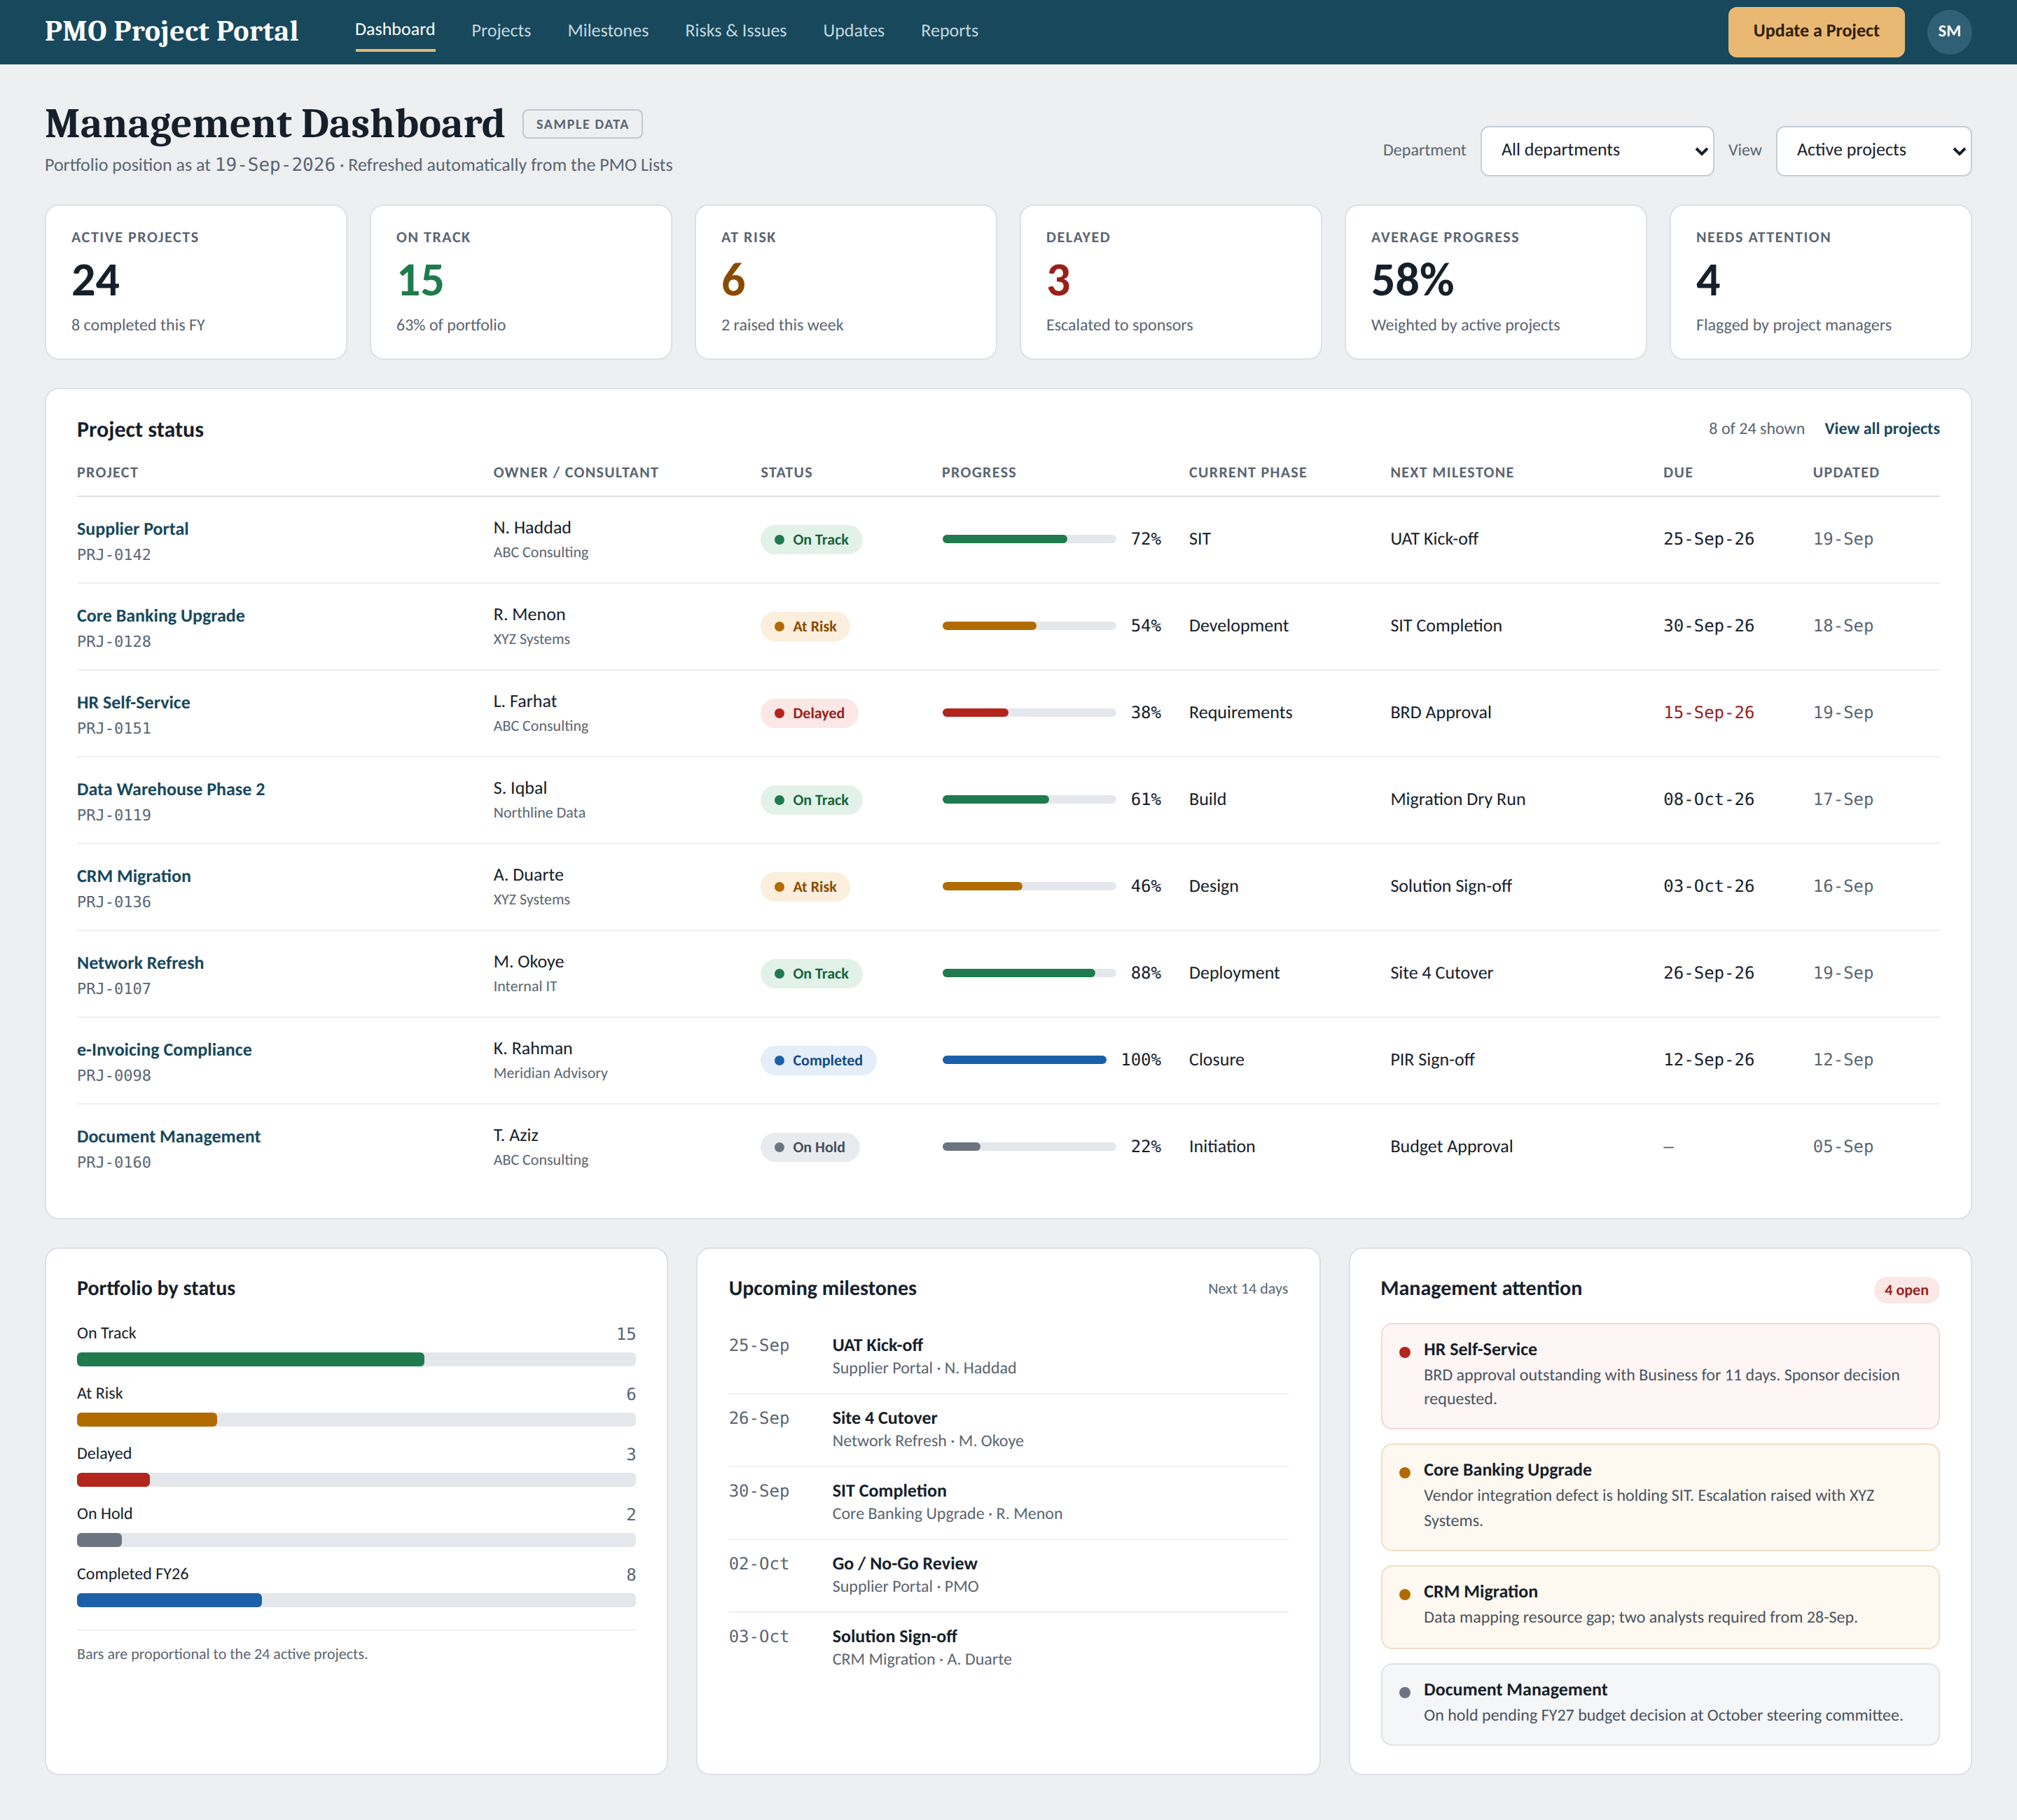
Screen 1 — Management dashboard. Sample data shown.

9.2 Project detail
Opened by selecting a project name on the dashboard. Overview and progress, the milestone plan with planned against actual dates, the risk and issue register, and the full update history showing how the project reached its current position.
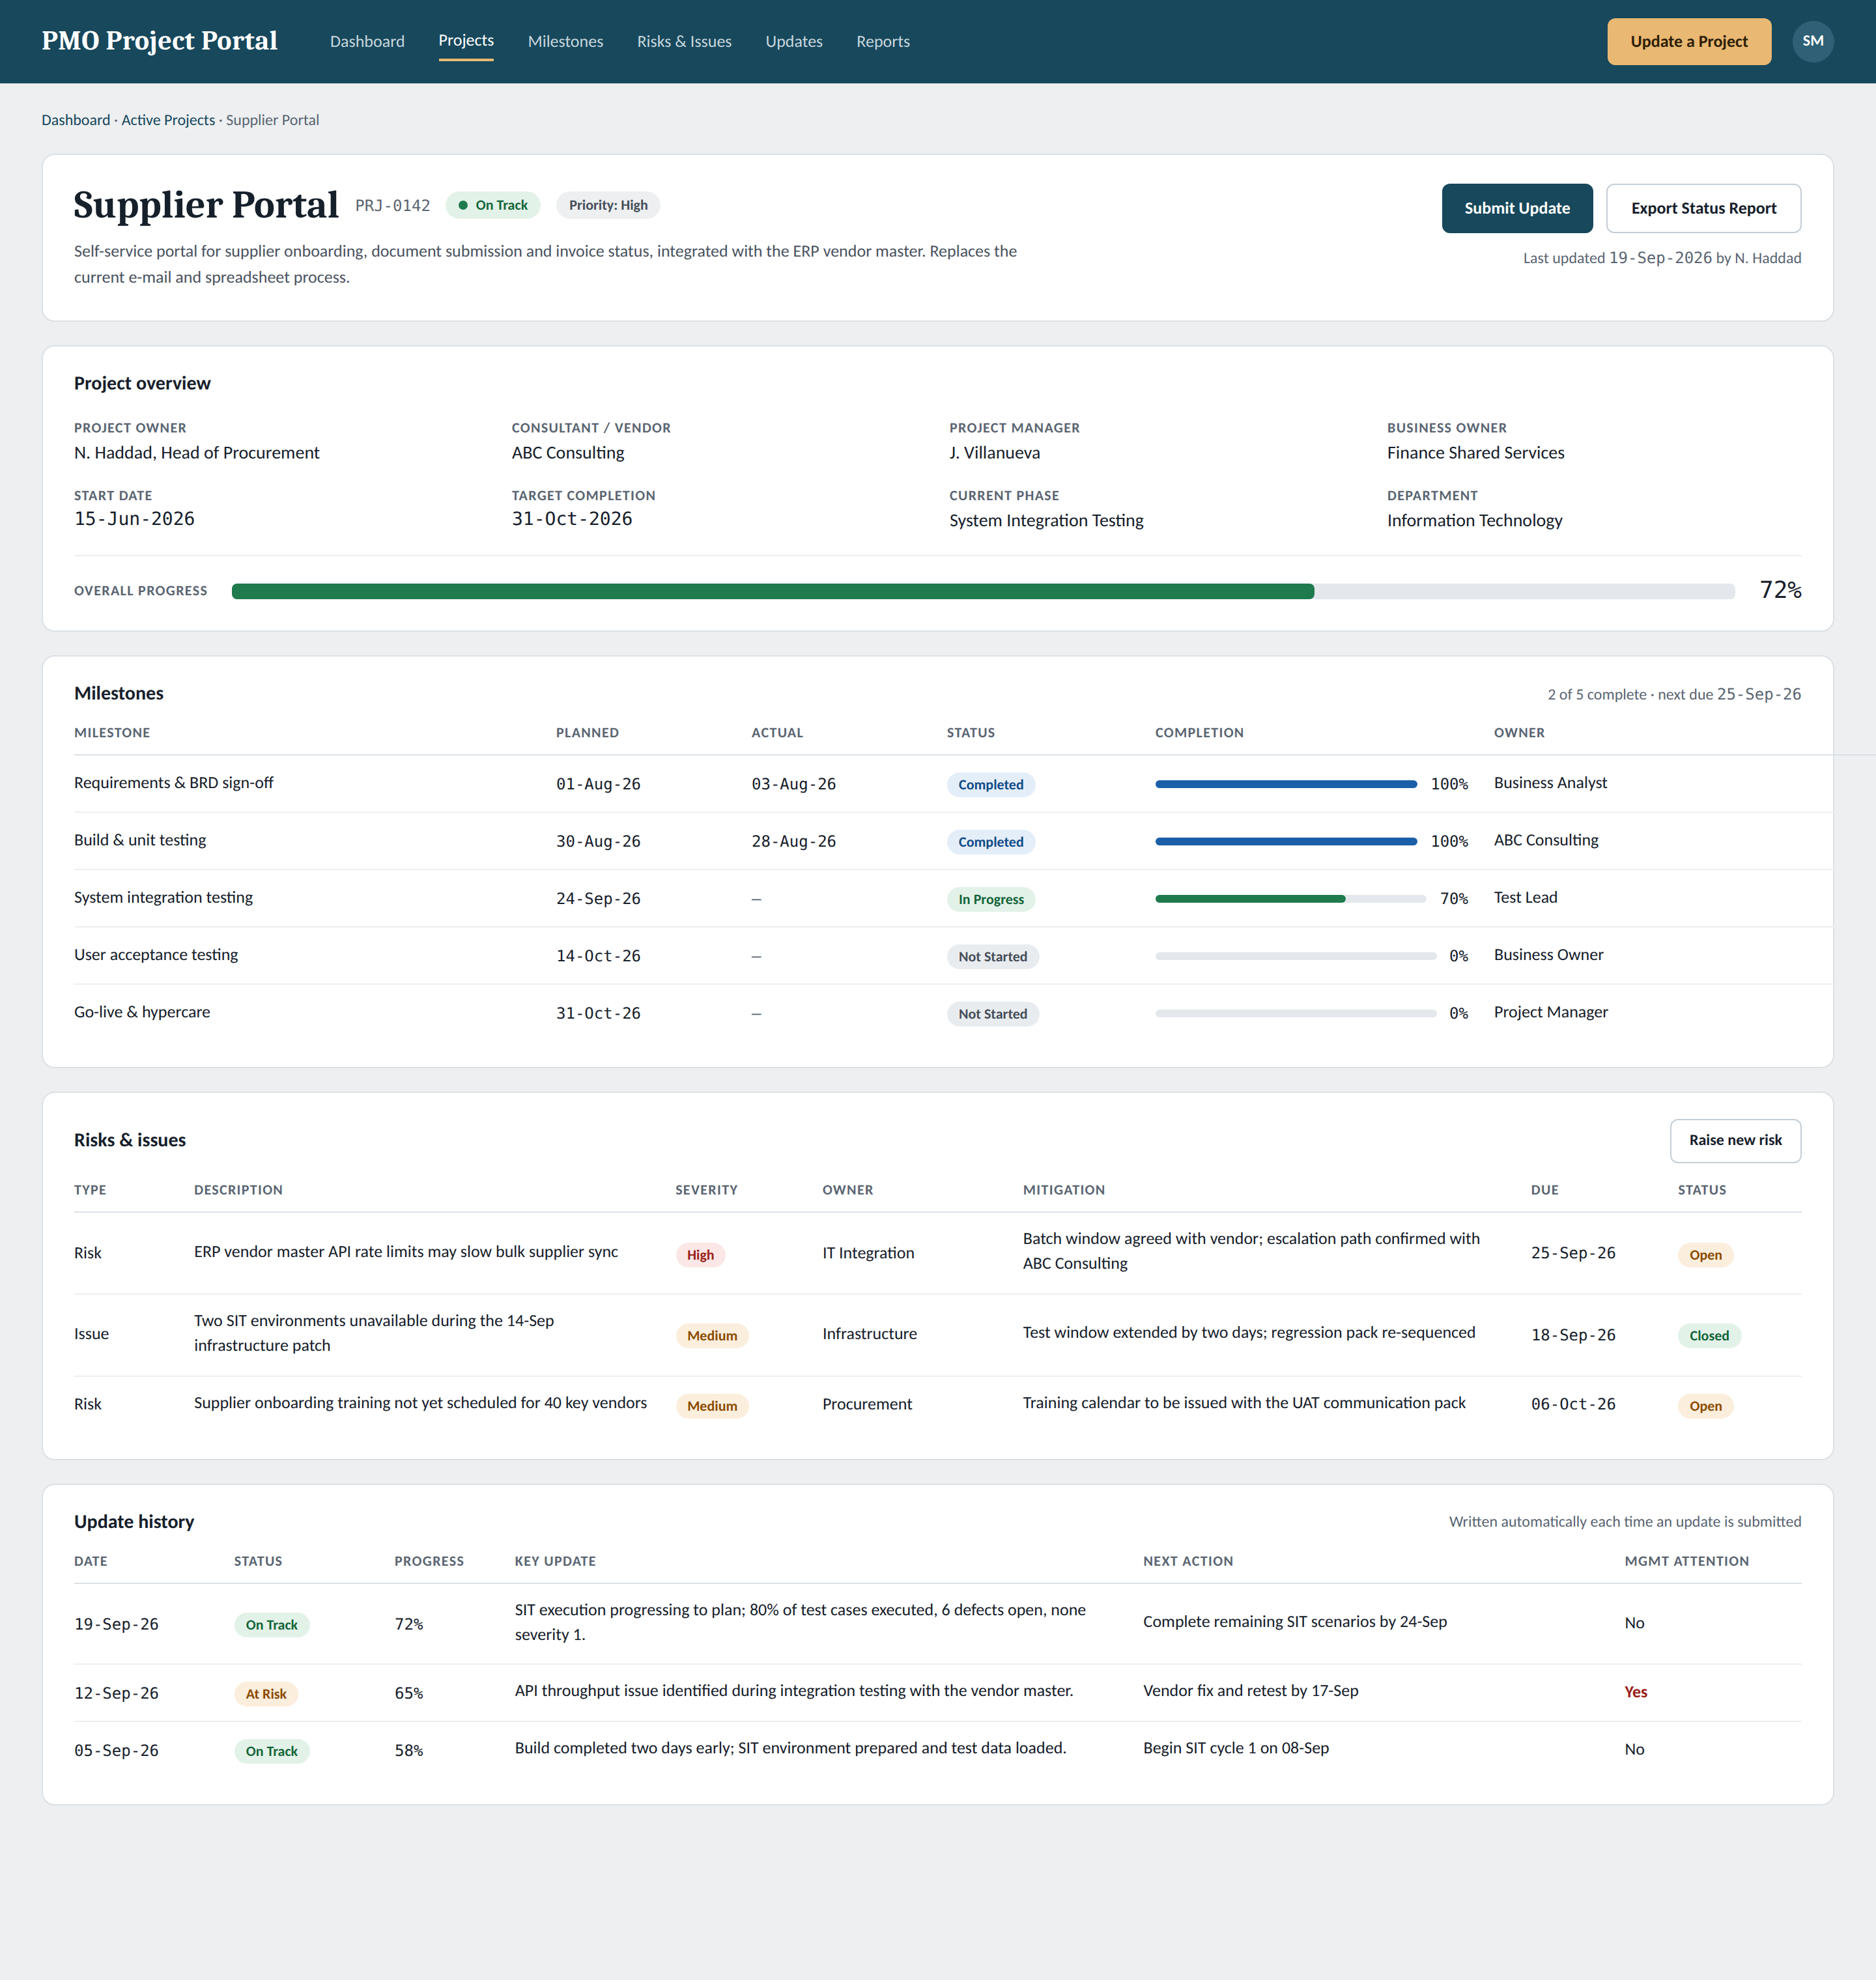
Screen 2 — Project detail page. Sample data shown.

9.3 Submit project update
The only place data is entered. Controlled status choices, progress, phase and milestone, key update and achievement, next action with owner and due date, and the management attention flag with its reason. Submitting writes both the current record and a dated history entry.
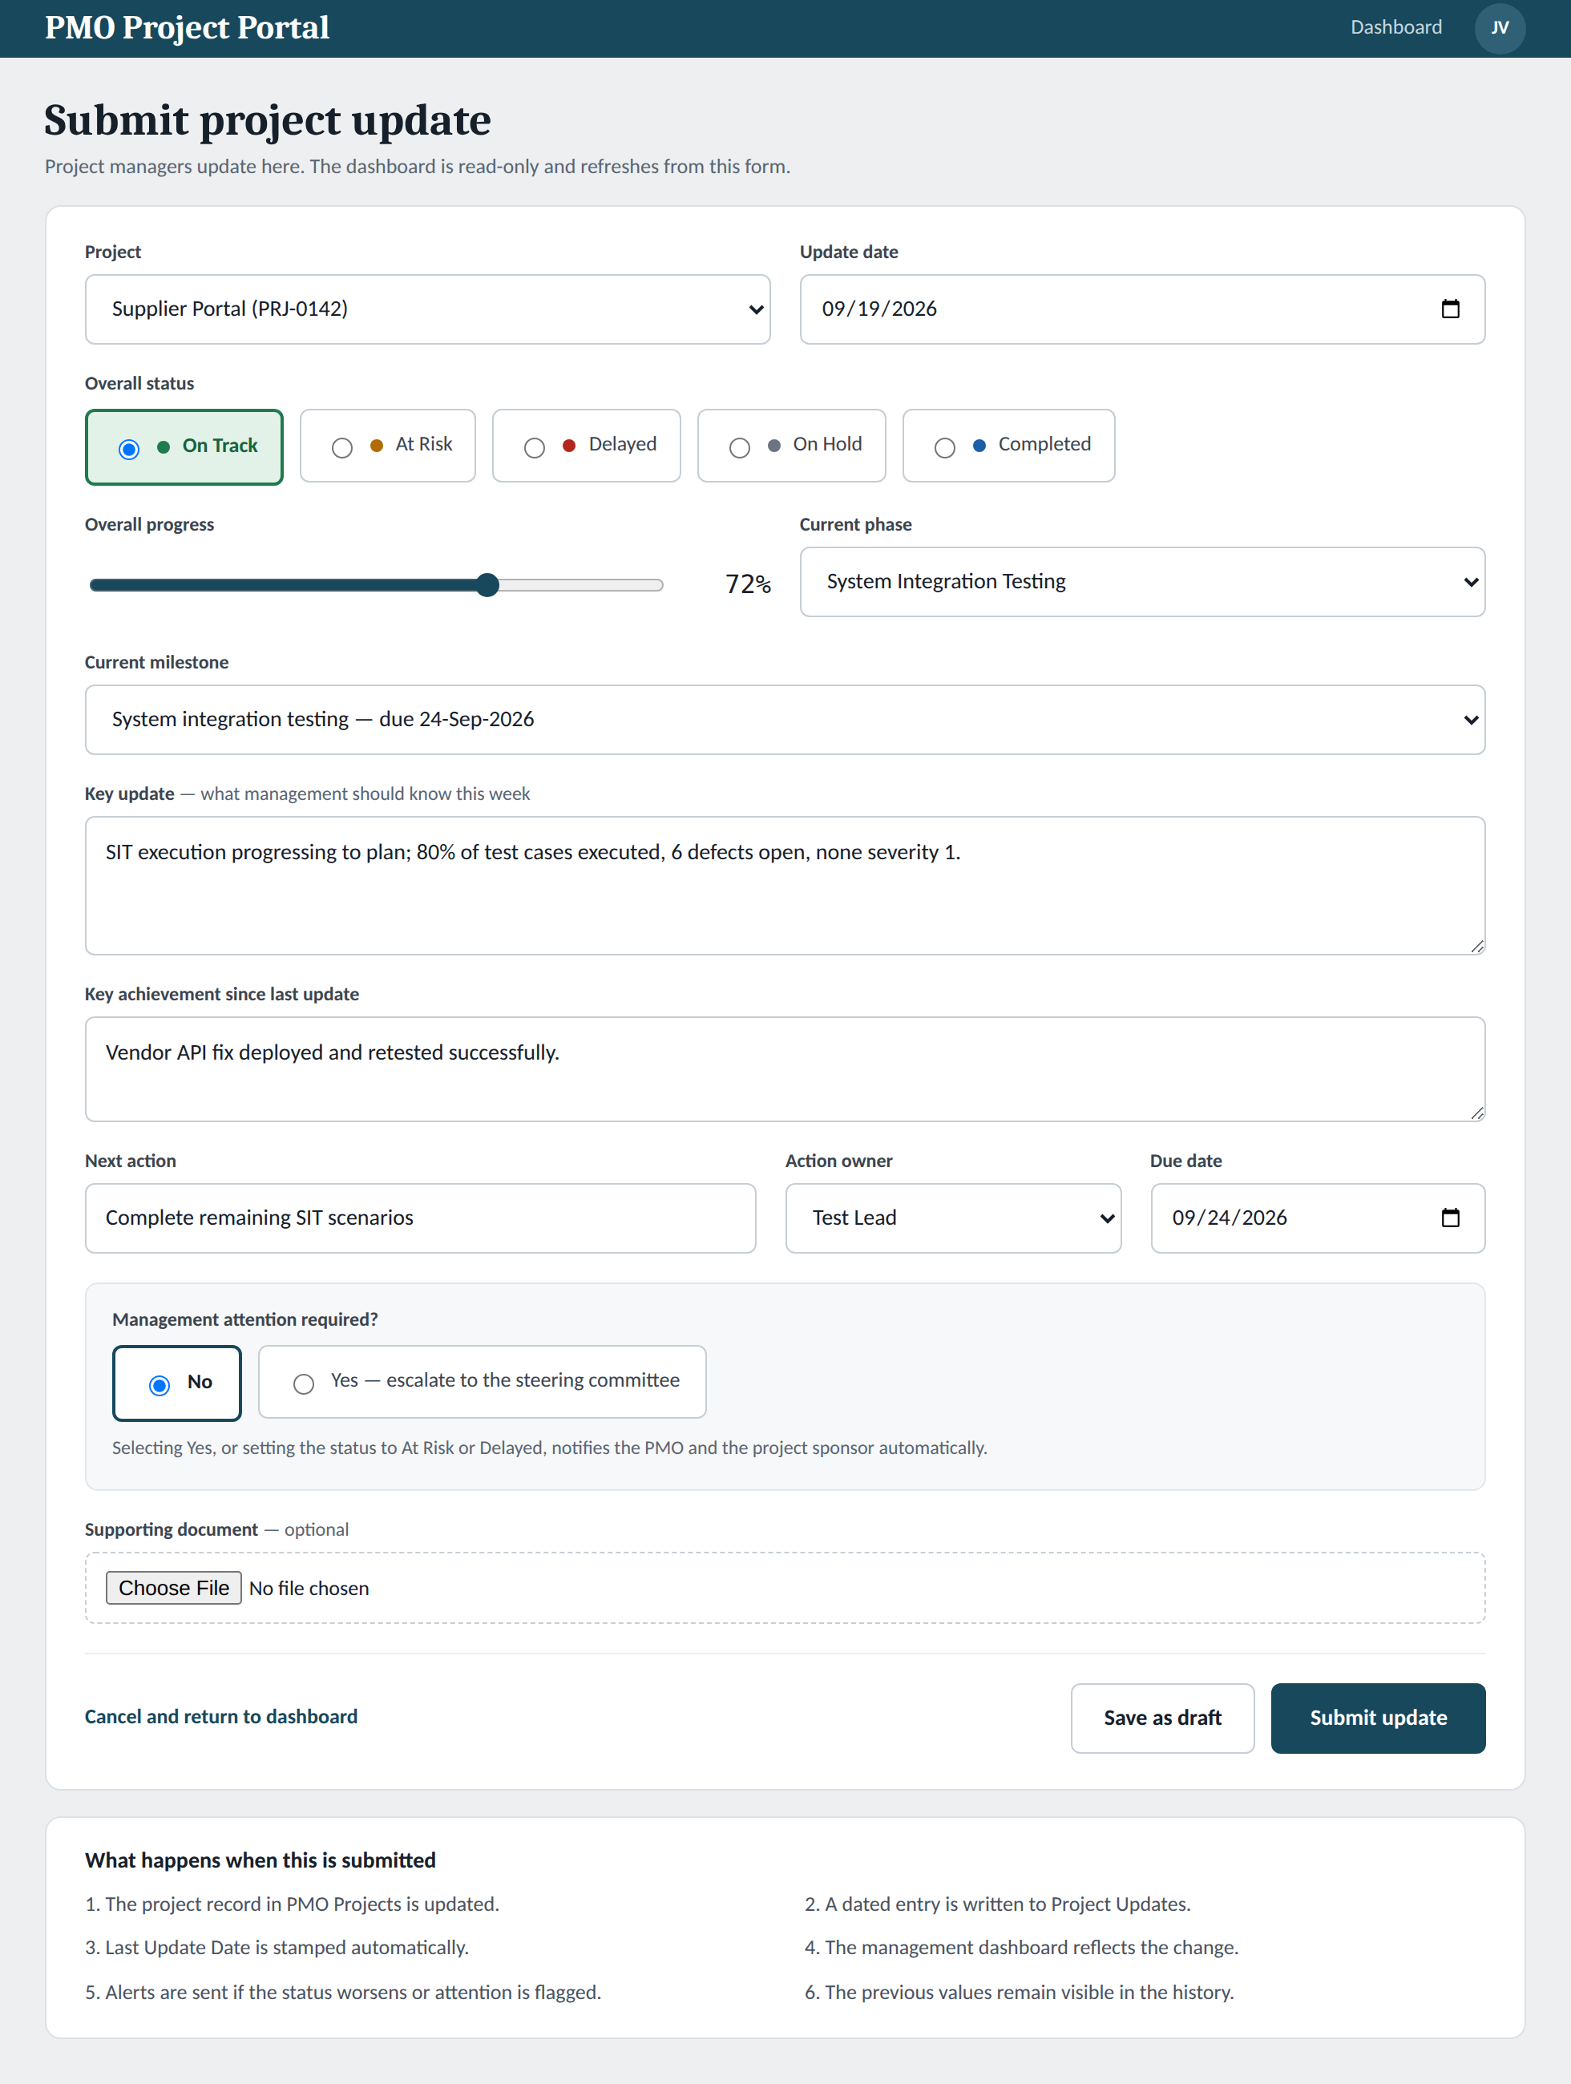
Screen 3 — Update form. Sample data shown.

10. Approval
By signing below, the approvers confirm that the requirements in this document are complete and correct, and that the solution may be built, tested and accepted on this basis.
After approval, any change to these requirements is raised as a change request, assessed for impact on effort and timeline, and approved by the Project Sponsor before it is built.

Name | Role | Signature | Date
Yousuf Akber Ali | Head of Real Estate Entities

